**UNCOVERING THE GAMING INDUSTRY'S HIDDEN GEMS: A COMREHENSIVE ANALYSIS OF VIDEO GAME SALES**

**INTRODUCTION**

Here we are studying about the sales of Games throught the years and there ranking in sales.

The projuct is used to track the sales of games and there popularity amoung us.

**PROBLEM DEFINITION AND DESING THINKING**

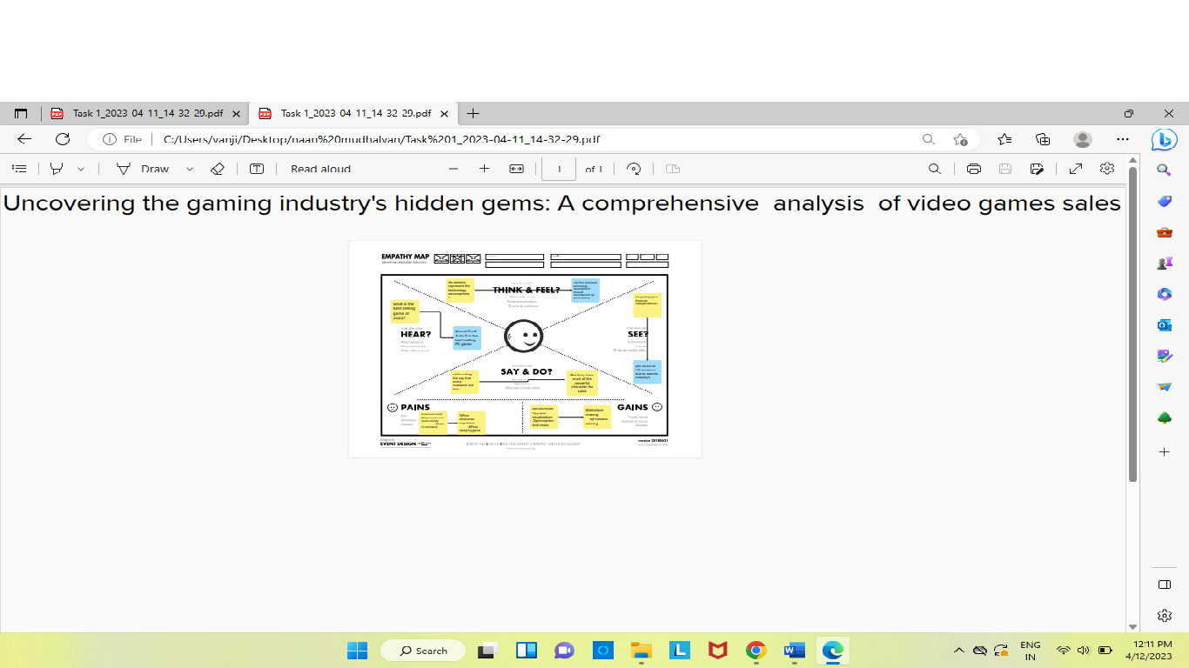

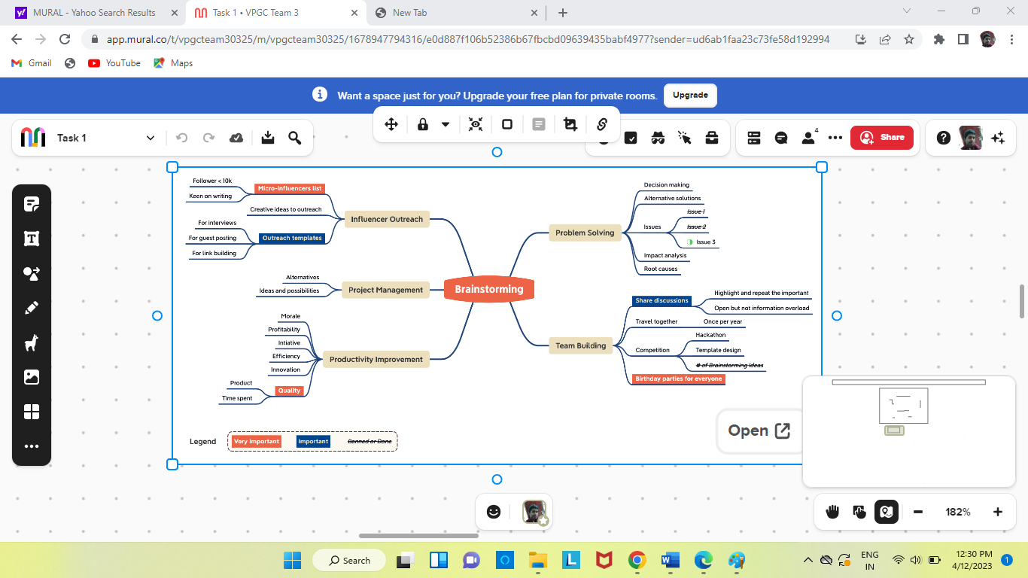

**RESULT**

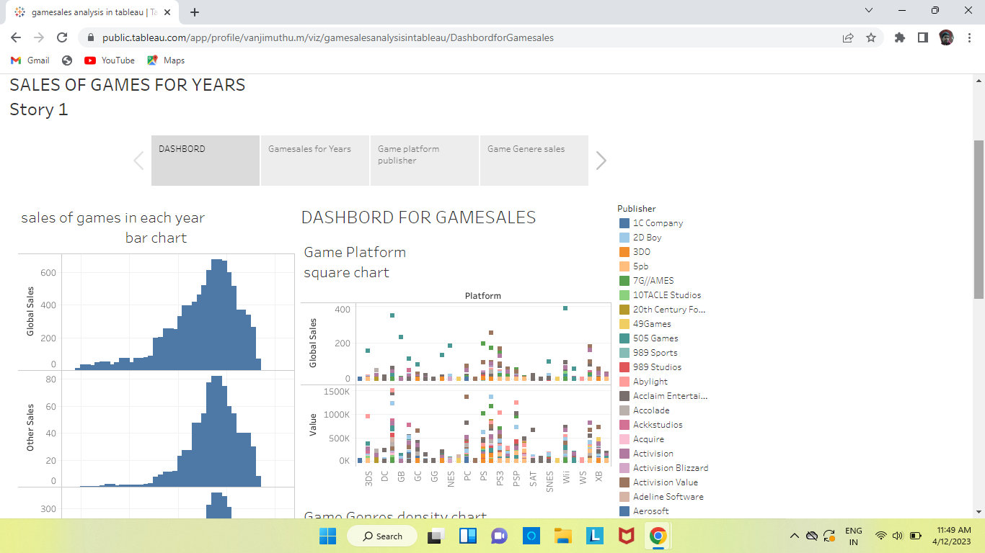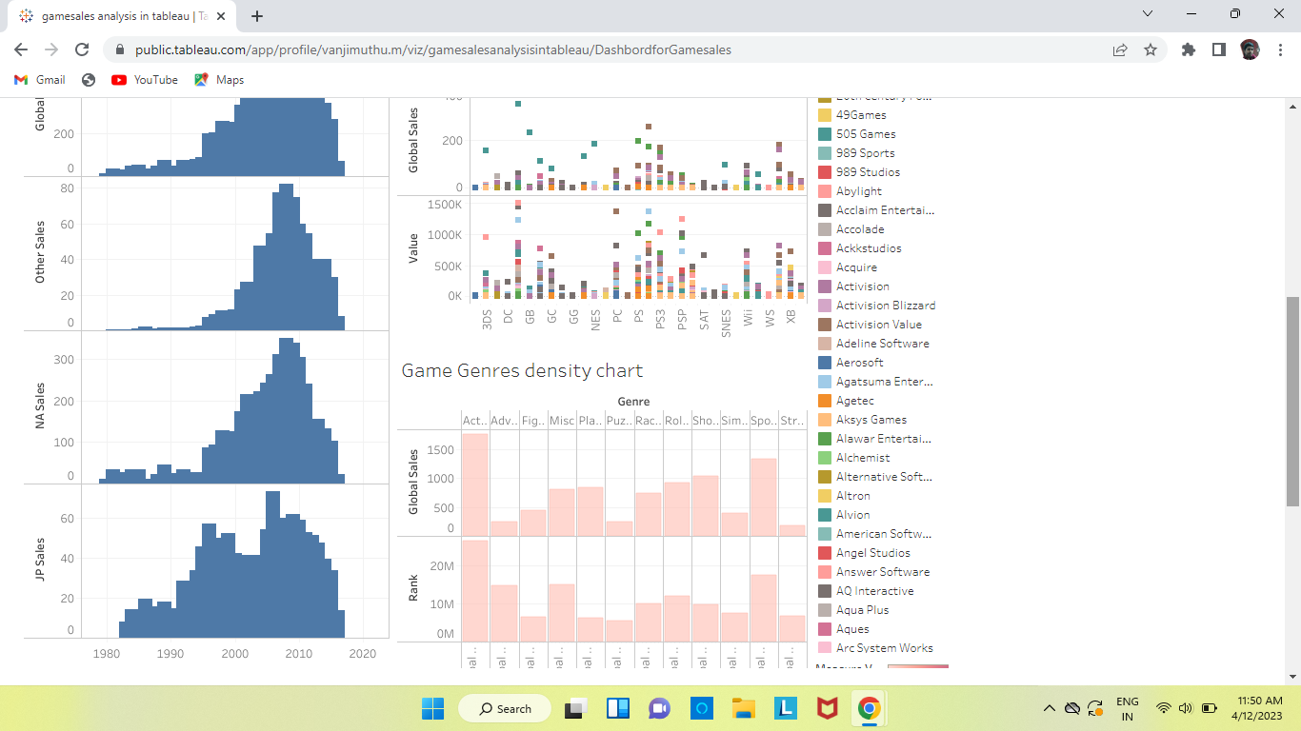

**ADVANTAGES**

* Increase in Job opportunity for Youth.
* Memory increasing.
* Spatial visualization.
* Perception and vision.
* Decision making.

**DISADVANTAGES**

* Depression and social anxiety.
* Lack of motivation.
* Poor emotional regulation.
* Poor sleep hygiene.

**APPLICATIONS**

The above given results can be used to promote the game sales and find the correct time for the publication of new games.

These results can be used to increase the advantages and decrease

The disadvantages of the game sales.

The above results can be used to increasing the quality of the game and correct the misgiving of the games.

**CONCLUSION**

This work gives us information about the sales of games through the years and year the increase in the sales of game.

**FUTURE SCOPE**

The game can be customized as user friendly and accessible easy way.